## Setting a budget

### Activity Diagram

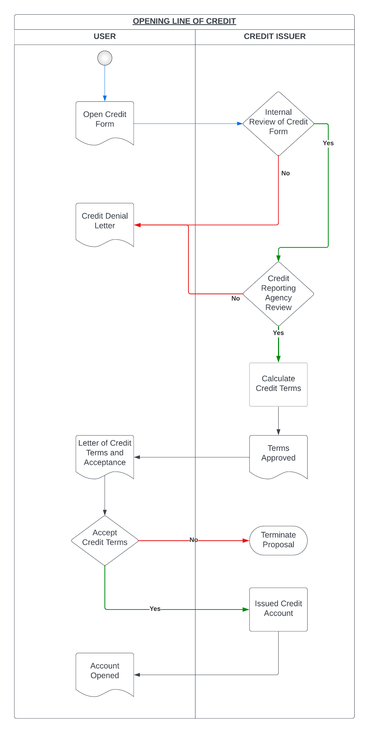

### Entities, attributes

| Entity | Description | Attributes | Example |
| --- | --- | --- | --- |
|  |  |  |  |
|  |  |  |  |
|  |  |  |  |
|  |  |  |  |
|  |  |  |  |

### ER Diagram

### Relationships

### Class Diagram